A linear regression is one of the easiest statistical models in machine learning. Understanding its algorithm is a crucial part .It is used to show the linear relationship between a dependent variable and one or more independent variables.

What is Regression?

Regression analysis is a form of predictive modeling technique which insvetigate the relationship between a dependent and independent variable.

Types of Regression
- Linear Regression
- Logistic Regression
- Polynomial Regression
- Stepwise Regression
- Least Square Method – Finding the best fit line
Least squares is a statistical method used to determine the best fit line or the regression line by minimizing the sum of squares created by a mathematical function. The “square” here refers to squaring the distance between a data point and the regression line. The line with the minimum value of the sum of square is the best-fit regression line.

Regression Line, y = mx+c where,
y = Dependent Variable
x= Independent Variable ;
c = y-Intercept
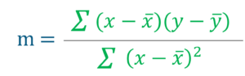

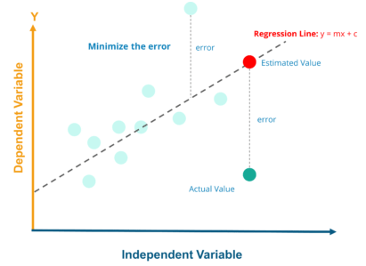

The value of m and c from above will be added to this equation
Q = c + m ∗ P

Plotting Linear Regression Line
Now that we have the equation of the line. So for each actual value of x, we will find the predicted values of y. Once we get the points we can plot them over and create the Linear Regression Line,

R Square Method – Goodness of Fit
R–squared value is the statistical measure to show how close the data are to the fitted regression line

y = actual value
y ̅ = mean value of y
yp = predicted value of y
